SIMATS ENGINEERING
ASSESSMENT TOOL 2

COURSE NAME: Database Management Systems
COURSE CODE: CSA05

COURSE OUTCOME COVERED

CO2: Apply the relational model, relational algebra, SQL query structures, and views to solve database querying and data manipulation problems. (BL3, BL6)

Activity Tool : Scenario-Based Task (High)
Assessment Tool Weightage: 35%

QUESTIONS Total Marks: 50
Q.No | Question | Bloom's Level | Marks
1 | Given the scenario of a School Management System, identify relations and write SQL to list all students with their class teacher and grade. | BL3 – Apply | 5
2 | A hospital wants to track patient appointments. Design the relational schema and write SQL to find doctors with more than 10 appointments this month. | BL3 – Apply | 5
3 | In an e-commerce scenario, write SQL queries using sub-queries to find products that have never been ordered. | BL3 – Apply | 5
4 | For a university database, write relational algebra expressions to find students enrolled in both 'DBMS' and 'OS' courses. | BL3 – Apply | 5
5 | Given a payroll scenario, create a view showing employees whose salary is below department average and write a query to update their salary by 10%. | BL6 – Create | 5
6 | In a banking scenario, apply JOIN operations to retrieve customer account details, transaction history, and branch information. | BL3 – Apply | 5
7 | A retail store needs daily sales summary. Write SQL with GROUP BY and HAVING to report total sales per category exceeding Rs. 10,000. | BL3 – Apply | 5
8 | For a library system scenario, construct tuple relational calculus expressions to find members who borrowed books from all genres. | BL3 – Apply | 5
9 | Given an inventory management scenario, define CHECK and FOREIGN KEY constraints and demonstrate their enforcement through SQL. | BL3 – Apply | 5
10 | Design a relational schema for an HR system and create materialized views for monthly attendance and performance summaries. | BL6 – Create | 5

Code of Conduct:

I MONISHA D/192311412 certify that this submission is my original work and that I have adhered to the guidelines specified for this assessment.
I understand that any violation of academic integrity rules will result in disciplinary action.

Signature of the student:
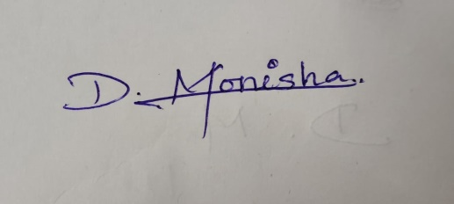
RUBRICS FOR CALCULATION:

Scenario based assessment
Criteria | Weightage (%) | Level 4 (Exemplary) | Level 3 (Proficient) | Level 2 (Developing) | Level 1 (Beginning)
Understanding of Scenario | 20% | Demonstrates clear and complete understanding of the scenario and context | Shows good understanding with minor gaps | Partial understanding; misses key aspects | Misinterprets or fails to understand the scenario
Identification of Key Issues | 20% | Accurately identifies all relevant issues and factors involved | Identifies most key issues with minor omissions | Identifies limited issues; some irrelevant points | Unable to identify key issues
Application of Concepts | 25% | Applies appropriate concepts effectively to address the scenario | Applies concepts with minor errors | Limited or partially correct application | Unable to apply relevant concepts
Decision Making | 20% | Makes well-reasoned, logical decisions with strong rationale | Makes reasonable decisions with some justification | Makes weak decisions with limited justification | No clear decisions made or rationale provided
Clarity of Response | 15% | Response is clear, structured, and logically presented | Generally clear with minor issues | Somewhat unclear or poorly structured | Disorganized and difficult to understand

Q1. School Management System — Students with Class Teacher and Grade
Scenario: A school needs to list every student along with the teacher who handles their class and the grade of that class.

Relations Identified
STUDENT (student_id PK, name, dob, class_id FK → CLASS.class_id)
CLASS (class_id PK, class_name, grade, teacher_id FK → TEACHER.teacher_id)
TEACHER (teacher_id PK, name, subject)
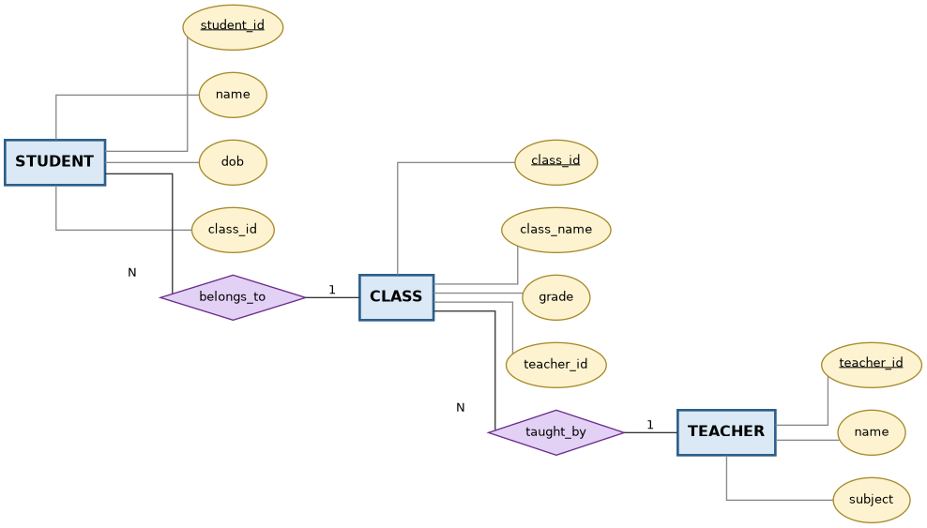
Fig 1.1 — ER Diagram: School Management System

SQL Query
SELECT s.student_id,
s.name AS student_name,
t.name AS class_teacher,
c.grade AS grade
FROM STUDENT s
JOIN CLASS c ON s.class_id = c.class_id
JOIN TEACHER t ON c.teacher_id = t.teacher_id
ORDER BY c.grade, s.name;
The query joins STUDENT to CLASS to identify each student's class, then joins CLASS to TEACHER to fetch the class teacher's name, producing one row per student with their teacher and grade.

Q2. Hospital — Patient Appointments
Scenario: A hospital wants to find doctors who have handled more than 10 appointments in the current month.

Relational Schema
PATIENT (patient_id PK, name, age, gender)
DOCTOR (doctor_id PK, name, specialization)
APPOINTMENT (appt_id PK, patient_id FK → PATIENT.patient_id,
doctor_id FK → DOCTOR.doctor_id, appt_date, status)
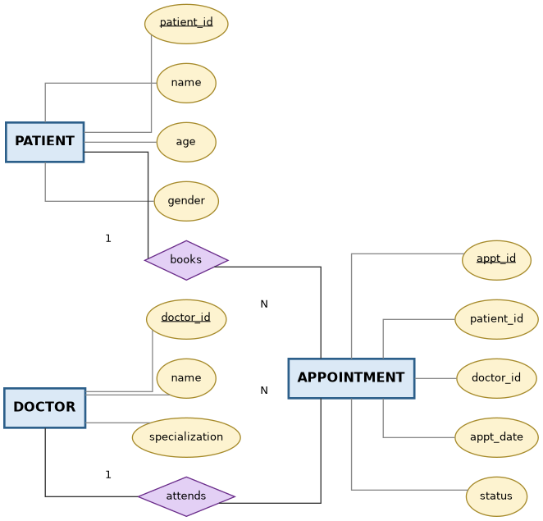
Fig 2.1 — ER Diagram: Hospital Appointment System

SQL Query
SELECT d.doctor_id,
d.name AS doctor_name,
COUNT(*) AS appointment_count
FROM DOCTOR d
JOIN APPOINTMENT a ON d.doctor_id = a.doctor_id
WHERE MONTH(a.appt_date) = MONTH(CURRENT_DATE)
AND YEAR(a.appt_date) = YEAR(CURRENT_DATE)
GROUP BY d.doctor_id, d.name
HAVING COUNT(*) > 10
ORDER BY appointment_count DESC;
WHERE filters appointments to the current month, GROUP BY aggregates per doctor, and HAVING keeps only doctors whose appointment count exceeds 10.

Q3. E-commerce — Products Never Ordered
Scenario: An e-commerce platform wants to identify products that have never appeared in any order, using sub-queries.

Relational Schema
CUSTOMER (customer_id PK, name, email)
ORDER (order_id PK, customer_id FK → CUSTOMER.customer_id, order_date)
PRODUCT (product_id PK, product_name, price)
ORDER_ITEM (order_item_id PK, order_id FK → ORDER.order_id,
product_id FK → PRODUCT.product_id, qty)
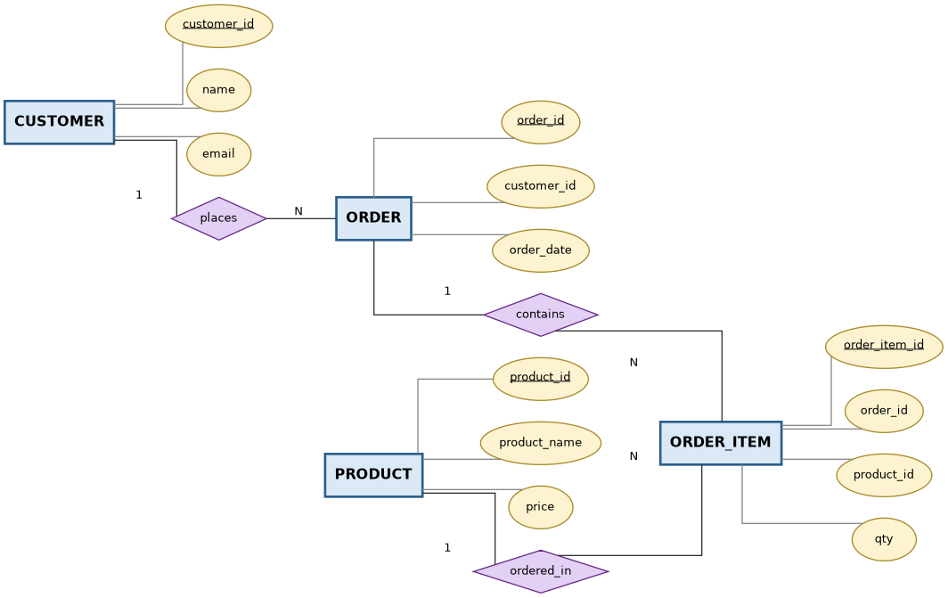
Fig 3.1 — ER Diagram: E-commerce Order System

SQL Query — Using NOT EXISTS (correlated sub-query)
SELECT p.product_id, p.product_name
FROM PRODUCT p
WHERE NOT EXISTS (
SELECT 1
FROM ORDER_ITEM oi
WHERE oi.product_id = p.product_id
);

Equivalent Query — Using NOT IN
SELECT product_id, product_name
FROM PRODUCT
WHERE product_id NOT IN (
SELECT product_id
FROM ORDER_ITEM
WHERE product_id IS NOT NULL
);
NOT EXISTS is generally preferred over NOT IN because NOT IN silently returns no rows if the sub-query result contains a NULL, whereas NOT EXISTS is NULL-safe.

Q4. University — Relational Algebra: Students Enrolled in Both DBMS and OS
Scenario: A university database must return students enrolled in both the 'DBMS' course and the 'OS' course.

Relations
STUDENT (student_id PK, name)
COURSE (course_id PK, course_name)
ENROLL (student_id FK → STUDENT.student_id, course_id FK → COURSE.course_id)

Relational Algebra Expression
DBMS_Students = π student_id ( σ course_name = 'DBMS' ( ENROLL ⋈ COURSE ) )

OS_Students = π student_id ( σ course_name = 'OS' ( ENROLL ⋈ COURSE ) )

Result = DBMS_Students ∩ OS_Students
Each course name is used to select the matching ENROLL rows (after joining with COURSE to translate course_id to course_name), student_id is projected out of each set, and the set INTERSECTION operator keeps only student_ids common to both — i.e. students enrolled in both DBMS and OS.

Q5. Payroll — View for Below-Average Salaries and Salary Update
Scenario: A payroll system must expose employees earning less than their department's average salary, then give all of them a 10% raise.

Relational Schema
DEPARTMENT (dept_id PK, dept_name)
EMPLOYEE (emp_id PK, name, dept_id FK → DEPARTMENT.dept_id, salary)

Step 1 — Create the View
CREATE VIEW BelowAvgSalary AS
SELECT e.emp_id,
e.name,
e.dept_id,
e.salary
FROM EMPLOYEE e
WHERE e.salary < (
SELECT AVG(e2.salary)
FROM EMPLOYEE e2
WHERE e2.dept_id = e.dept_id
);

Step 2 — Update Salaries of Employees in the View by 10%
UPDATE EMPLOYEE
SET salary = salary * 1.10
WHERE emp_id IN ( SELECT emp_id FROM BelowAvgSalary );
The view uses a correlated sub-query to compute each department's average salary and compares every employee's own salary against it. The UPDATE statement then re-uses the view to target exactly those under-paid employees and raises their salary by 10%. Note: after the UPDATE, the view's result set changes automatically because it is a virtual table re-evaluated on every access.

Q6. Banking — JOINs Across Customer, Account, Transaction, Branch
Scenario: A bank wants a consolidated view of customer details, their account(s), transaction history, and the branch that maintains each account.

Relational Schema
CUSTOMER (customer_id PK, name, address)
BRANCH (branch_id PK, branch_name, city)
ACCOUNT (account_no PK, customer_id FK → CUSTOMER.customer_id,
branch_id FK → BRANCH.branch_id, acc_type, balance)
TRANSACTION (txn_id PK, account_no FK → ACCOUNT.account_no,
txn_date, amount, txn_type)
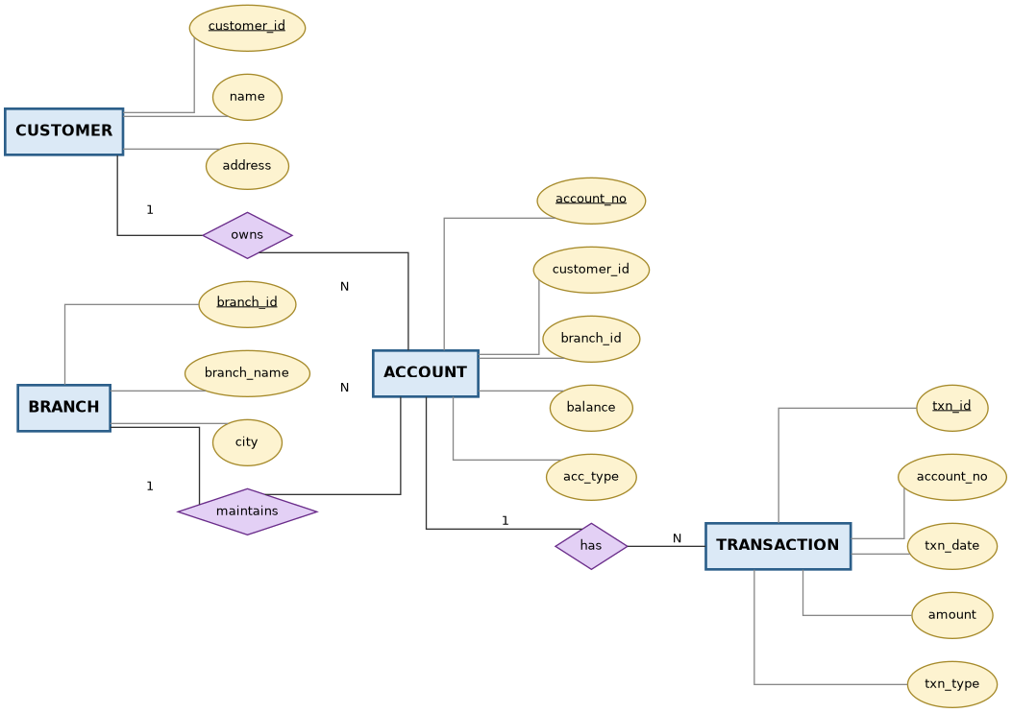
Fig 6.1 — ER Diagram: Banking System

SQL Query
SELECT c.customer_id, c.name AS customer_name,
a.account_no, a.acc_type, a.balance,
b.branch_name, b.city,
t.txn_id, t.txn_date, t.amount, t.txn_type
FROM CUSTOMER c
JOIN ACCOUNT a ON c.customer_id = a.customer_id
JOIN BRANCH b ON a.branch_id = b.branch_id
LEFT JOIN TRANSACTION t ON a.account_no = t.account_no
ORDER BY c.customer_id, t.txn_date;
INNER JOINs bring together CUSTOMER, ACCOUNT and BRANCH since every account must have an owner and a branch. A LEFT JOIN is used for TRANSACTION so that accounts with no transactions yet still appear in the result (with NULL transaction columns).

Q7. Retail — Daily Sales Summary by Category
Scenario: A retail store wants the total sales per product category, reporting only categories whose sales exceed Rs. 10,000.

Relational Schema
PRODUCT (product_id PK, product_name, category)
SALES (sale_id PK, product_id FK → PRODUCT.product_id,
sale_amount, sale_date)

SQL Query
SELECT p.category,
SUM(s.sale_amount) AS total_sales
FROM SALES s
JOIN PRODUCT p ON s.product_id = p.product_id
WHERE s.sale_date = CURRENT_DATE
GROUP BY p.category
HAVING SUM(s.sale_amount) > 10000
ORDER BY total_sales DESC;
GROUP BY collapses rows to one per category; SUM computes the category's daily revenue; HAVING filters groups (not individual rows) to keep only categories that crossed Rs. 10,000 in sales, which WHERE cannot do because it runs before aggregation.

Q8. Library — Tuple Relational Calculus: Members Who Borrowed from All Genres
Scenario: A library wants to find members who have borrowed at least one book from every genre in the catalogue — a relational-division type query.

Relations
MEMBER (member_id PK, name)
BOOK (book_id PK, title, genre)
BORROW (member_id FK → MEMBER.member_id, book_id FK → BOOK.book_id, borrow_date)

Tuple Relational Calculus Expression
{ t | ∃ m ∈ MEMBER ( t.member_id = m.member_id ) ∧
∀ g ( g ∈ { u.genre | u ∈ BOOK } →
∃ br ∈ BORROW ( ∃ b ∈ BOOK (
br.book_id = b.book_id ∧
b.genre = g ∧
br.member_id = t.member_id ) ) ) }
This TRC expression reads as: return every tuple t whose member_id belongs to MEMBER, such that for every genre g present in BOOK, there exists a BORROW record for that member linked to a book of genre g. The universal quantifier (∀) over genres combined with the existential quantifier (∃) over matching borrow rows implements relational division — the member must satisfy the condition for all genres, not just one.

Q9. Inventory Management — CHECK and FOREIGN KEY Constraints
Scenario: An inventory system must ensure stock quantities never go negative and that every product references a valid, existing supplier.

Relational Schema
SUPPLIER (supplier_id PK, name, contact)
PRODUCT (product_id PK, product_name, supplier_id FK → SUPPLIER.supplier_id,
category, qty_on_hand, reorder_level)
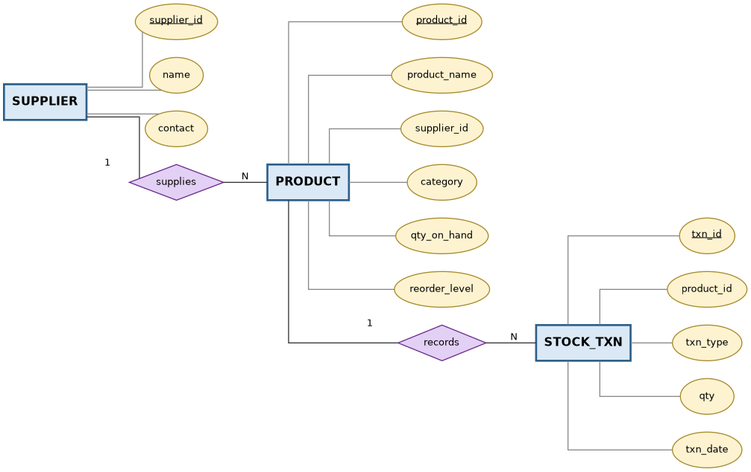
Fig 9.1 — ER Diagram: Inventory Management System

DDL — Defining the Constraints
CREATE TABLE SUPPLIER (
supplier_id INT PRIMARY KEY,
name VARCHAR(100) NOT NULL,
contact VARCHAR(15)
);

CREATE TABLE PRODUCT (
product_id INT PRIMARY KEY,
product_name VARCHAR(100) NOT NULL,
supplier_id INT,
category VARCHAR(50),
qty_on_hand INT DEFAULT 0 CHECK (qty_on_hand >= 0),
reorder_level INT DEFAULT 0 CHECK (reorder_level >= 0),
CONSTRAINT fk_product_supplier
FOREIGN KEY (supplier_id) REFERENCES SUPPLIER(supplier_id)
ON DELETE SET NULL ON UPDATE CASCADE
);

Demonstrating Enforcement
-- (a) Violates CHECK constraint: negative stock is not allowed
INSERT INTO PRODUCT (product_id, product_name, supplier_id, category,
qty_on_hand, reorder_level)
VALUES (101, 'Widget', 1, 'Hardware', -5, 10);
-- Result: ERROR - CHECK constraint 'qty_on_hand >= 0' violated

-- (b) Violates FOREIGN KEY constraint: supplier 999 does not exist
INSERT INTO PRODUCT (product_id, product_name, supplier_id, category,
qty_on_hand, reorder_level)
VALUES (102, 'Gadget', 999, 'Electronics', 20, 5);
-- Result: ERROR - foreign key constraint 'fk_product_supplier' violated

-- (c) Valid insert: satisfies both constraints
INSERT INTO PRODUCT (product_id, product_name, supplier_id, category,
qty_on_hand, reorder_level)
VALUES (103, 'Cable', 1, 'Accessories', 50, 15);
-- Result: 1 row inserted successfully

Q10. HR System — Materialized Views for Attendance and Performance
Scenario: An HR system needs pre-computed monthly summaries of employee attendance and performance so reports load instantly instead of re-aggregating large transactional tables every time.

Relational Schema
DEPARTMENT (dept_id PK, dept_name)
EMPLOYEE (emp_id PK, name, dept_id FK → DEPARTMENT.dept_id,
designation, join_date)
ATTENDANCE (attendance_id PK, emp_id FK → EMPLOYEE.emp_id,
att_date, status) -- status: Present / Absent / Leave
PERFORMANCE (perf_id PK, emp_id FK → EMPLOYEE.emp_id,
month, rating) -- rating: 1-5 scale
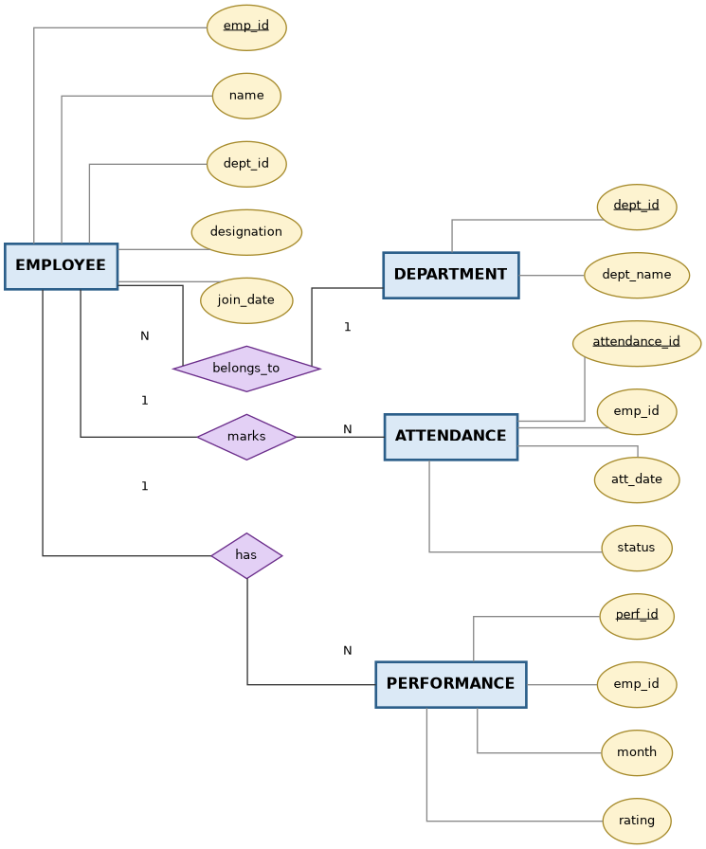
Fig 10.1 — ER Diagram: HR System

Materialized View 1 — Monthly Attendance Summary
CREATE MATERIALIZED VIEW monthly_attendance_summary AS
SELECT emp_id,
DATE_TRUNC('month', att_date) AS att_month,
COUNT(*) FILTER (WHERE status = 'Present') AS days_present,
COUNT(*) FILTER (WHERE status = 'Absent') AS days_absent,
COUNT(*) FILTER (WHERE status = 'Leave') AS days_on_leave,
COUNT(*) AS days_recorded
FROM ATTENDANCE
GROUP BY emp_id, DATE_TRUNC('month', att_date);

Materialized View 2 — Monthly Performance Summary
CREATE MATERIALIZED VIEW monthly_performance_summary AS
SELECT emp_id,
month,
ROUND(AVG(rating), 2) AS avg_rating,
MIN(rating) AS min_rating,
MAX(rating) AS max_rating
FROM PERFORMANCE
GROUP BY emp_id, month;

Keeping the Views Current
-- Materialized views store the data physically, so they must be
-- refreshed after new attendance / performance rows are loaded:
REFRESH MATERIALIZED VIEW monthly_attendance_summary;
REFRESH MATERIALIZED VIEW monthly_performance_summary;
Unlike an ordinary (virtual) view, a materialized view physically persists its result set, so HR dashboards querying monthly summaries avoid re-scanning and re-aggregating the full ATTENDANCE and PERFORMANCE tables on every request. The trade-off is that the data can go stale until the next REFRESH — acceptable here since attendance/performance reporting is naturally a monthly, not real-time, operation.

